Experimental Validation of a Solid-State Thermal Management System of a MW-Scale Electric Aircraft
Ramy Abdelmaksoud, Calin Tarau, Jeffrey Diebold, Kuan-Lin Lee
Advanced Cooling Technologies, Lancaster, PA, 17601, USA
Luis A. Rodriguez and Rodger W. Dyson
NASA Glenn Research Center, Cleveland, OH, 44035
Thermal management represents a significant challenge for Megawatt-class electric aircraft due to the large quantity of low-grade waste heat that must be dissipated. NASA Glenn Research Center (GRC) developed a novel solid-state thermal management system that can solve this challenge. Advanced Cooling Technologies Inc. (ACT) has been working with NASA GRC developing a large-scale prototype of the novel solid-state thermal management system. In previous publications, ACT discussed the development process and testing of each component in the large-scale prototype. In this paper, an experimental validation of the large-scale prototype, after it was assembled, is discussed.
- Nomenclature
ACT = Advanced Cooling Technologies
DC = Direct Current
EDU = Engineering Demonstration Unit
GRC = NASA Glenn Research Center
ID = Inside diameter
K = Kelvin or Potassium
MW = Megawatt
OD = Outside diameter
SS = Stainless steel
TAHP = Thermoacoustic Heat Pump
- Introduction
Electrified Aircraft Propulsion (EAP) systems utilize electrical motors to provide some or all the thrust for an aircraft. Potential benefits of EAP include (1) low carbon emission (2) low noise (3) reduced fuel consumption (4) low operating cost and (5) high performance. NASA is currently leading the development of EAP technology in the U.S. The near-term goal is to realize a MW-class, commercial electric aircraft by 2035. Thermal management is a key challenge for MW-class electric aircraft due to the large amounts of high and low-grade waste heat. Low-grade waste heat is more difficult to reject due to the smaller temperature difference and limited surface area. Table 1 shows the current thermal management systems and their disadvantages [1].
Table 1: Present Thermal Management Solutions [1].
Thermal Management Technology | Disadvantage
Ram air HX | Adds weight, aircraft drag, displaces fuel capacity
Convective skin cooling HX | Adds weight, drag, and requires liquid pumping losses
Sinking heat into fuel | Limited thermal capacity due to coking and volume
Sinking heat into lubricating oil | Limited thermal capacity, Low delta T adds HX mass
Active cooling | Reduces propulsive efficiency, Adds weight and maintenance
Phase change cooling | Limited thermal capacity, Adds weight
Heat Pipe, Pumped Multiphase | Does not increase Exergy which impacts mass and efficiency

To fulfill this vision, advanced thermal management technologies that can handle (i.e., recycle, deliver, and reject) all low-grade waste heat (~kW) generated within an aircraft is highly needed. NASA Glenn Research Center (GRC), Dyson et al. [2], developed a novel system called “Thermal Recovery Energy Efficient System” (TREES), which is mainly based on thermoacoustics (thermoacoustic heat pump “TAHP” concept). The TREES distributes the acoustic wave via multiple acoustic tubes to acoustic heat pumps, where the low-grade waste heat is recovered and elevated to a high temperature. Then the system uses a heat pipe-based heat transfer network to deliver the high-grade heat back to various locations on the airplane asking for thermal energy (e.g., heating combustion air, wing de-icing etc.) (see Figure 1). These heat sinks will be referred to as “end users.” Acoustic waves generated by waste heat are used to refrigerate “Aircraft heat sources”. Dominant heat sources on the airplane include power system, circuit breakers, cabin cooling and others (avionics, actuation, gearboxes etc.). Their power, temperature and location are summarized in [3]. Potential heat end users (systems onboard the aircraft that benefit from thermal energy) and their temperature and location information can be found in [3]. An illustration of the thermosyphon network for electric aircraft applications is shown in Figure 2.
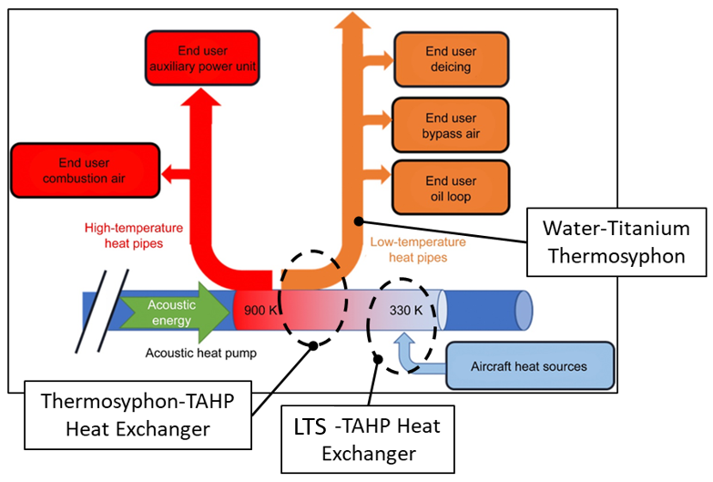Fig. 1 Illustration of thermoacoustic heat pump and thermosyphon based thermal management system [5].

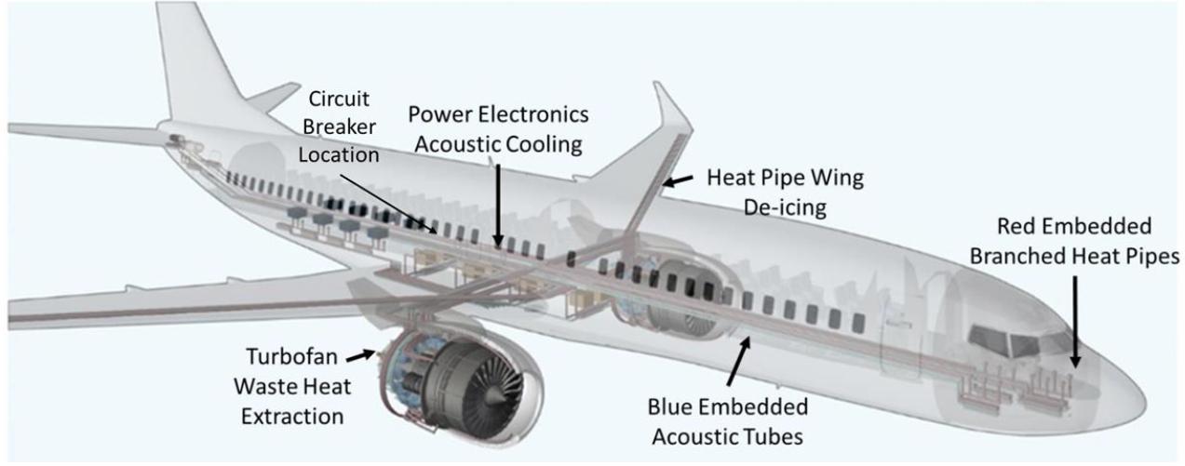
Fig. 2 Illustration of the heat pipe network for electric aircraft applications [4].
TREES was successfully modeled and fabricated at NASA GRC to demonstrate a TMS solution for electric aircraft. TREES demonstrated the ability to convert mechanical energy to acoustic over various distances, with minimal energy dissipation. Also, amplification of acoustic energy was successfully demonstrated. More details on the TREES prototypes development and testing at NASA GRC can be found in [1].
ACT has been working with NASA GRC to develop a large-scale TAHP for a 1-MW scale electric aircraft and integrate it with two passive two-phase heat transfer devices (a loop thermosyphon to take the low-grade waste heat from the circuit breaker and transfer it to the TAHP and a thermosyphon to take that recovered high-grade waste heat from the TAHP and transfer it to multiple locations on the aircraft). The development process of the large-scale TAHP at ACT is explained in [5], the loop thermosyphon development and its integration with the circuit breaker is discussed in [5], and the thermosyphon network development and testing is discussed in [6, 3, 7]. This paper is a continuation of the previous work. In this paper, the preliminary testing of the whole system (TAHP + thermosyphon) is presented.
- Overview of the Engineering Demonstration Unit (EDU)

Figure 3 shows a CAD model of the whole EDU including a total of 5 technologies (i.e., TAHP, titanium-water (Ti-H2O) thermosyphon, stainless-steel-potassium (SS-K) high temperature thermosyphon, stainless-steel-water (SS-H2O) loop thermosyphon, and 1MW circuit breaker) integrated together. The Ti-H2O thermosyphon, SS-K high temperature thermosyphon, and SS-H2O loop thermosyphon are all integrated into the TAHP via annular jackets (i.e., annular space resulted by welding a larger pipe to the TAHP).

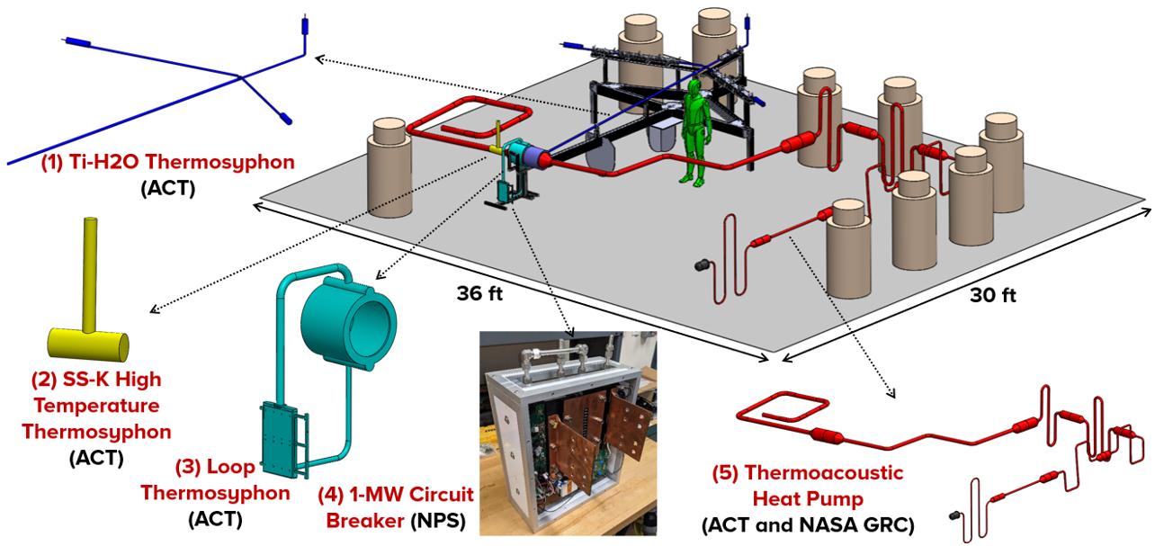
Fig. 3 A CAD model of the whole EDU. Four technologies (i.e., Ti-H2O thermosyphon, SS-K high temperature thermosyphon, SS-H2O loop thermosyphon, and 1MW circuit breaker) are integrated into the TAHP [5].

The TAHP is a closed system that contains pressurized helium gas. The TAHP starts with a wave generator followed by a thermal buffer tube (TBT) and six amplification stages connected in series. Each stage consists of a transition tube (conical shape), heat stage (straight tube), cascade tube (conical shape), and thermal buffer tubes. Each heat stage consists of one copper and one aluminum heat exchangers and stainless-steel mesh stacked in between them. Each stage (heat engine) of the TAHP consists of three components: two heat exchangers and a stainless-steel mesh stack between them. The copper heat exchangers have multiple holes where the helium flows through. The purpose of the heat engines is to use thermal energy to amplify the acoustic wave generated by the wave generator. At the heat pump stage, the TAHP will remove the heat (about 2.6 kW at 282K) from the fault management system (circuit breaker) and supply it to the titanium thermosyphon at 350 K. The water thermosyphon will transport that heat to the required end users on the aircraft (e.g., deicing, cabin air, combustion, etc.). Heat will be supplied to the TAHP in the first 6 stages (amplification stages) by high temperature band heaters while liquid nitrogen will be used for cooling in the cooling jackets (see Fig. 4). Band heaters are used to mimic the waste heat from the engine in the real application.
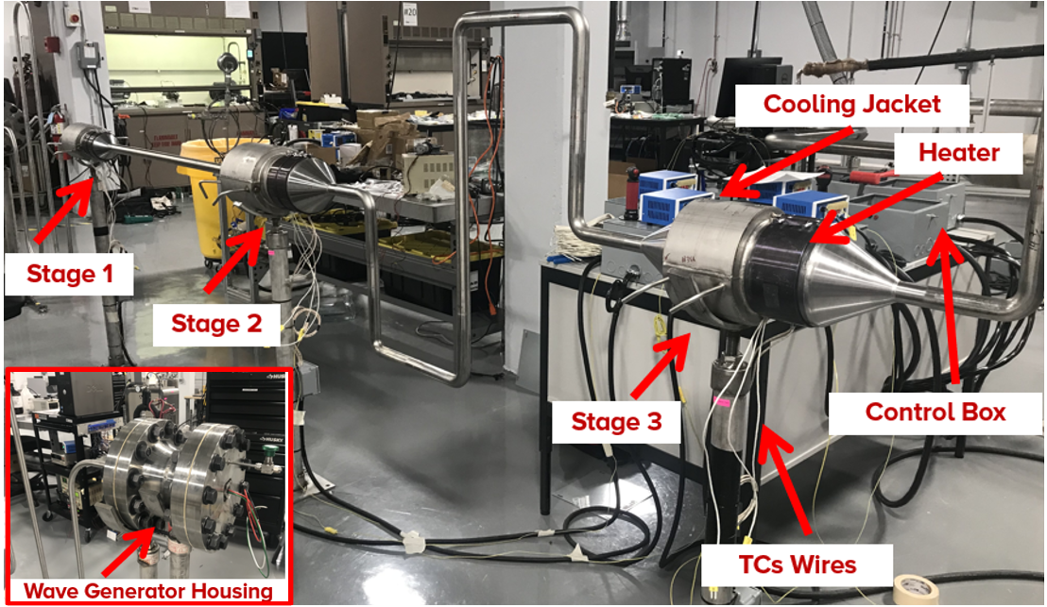
Fig. 4 Band heaters and cooling jackets of the stages (only Stages 1-3 are shown).

- Experimental Validation Procedure of the EDU
ACT completed the assembly of the TAHP and its integration to the thermosyphon (see Fig. 5). The instrumentation installation (e.g., thermocouples, controllers, pressure transducers, etc.) is completed. Fig. 6 shows the TCs layout on the TAHP and thermosyphon (EDU). More than 70 TCs and two pressure transducers (PT) were installed on the EDU.
ACT performed a series of different tests. The following list shows the systematic testing procedure.
- Pressure test of TAHP at room temperature
- Pressure test of TAHP at elevated temperatures
- Testing the TAHP without the amplification stages (only the motor is ON)
- Testing the TAHP with turning on each stage at a time
- Testing the TAHP under the design operating conditions
Both pressure tests were successful. Multiple preliminary tests were performed to optimize the wave generate frequency range and the heating and cooling performance at the amplification stages.
Fig. 5 Photo of the EDU.
Fig. 6 TCs layout.
- Experimental Validation Results
- Testing the TAHP without the amplification stages (only the motor is ON)
Figure 7 shows the temperature measurements along the TAHP stages with no heating or cooling (i.e., only the wave generator is turned on). It can be seen that the thermoacoustic effect is noticed in the first stage (e.g., a temperature difference of around 35˚C across Stage 1 is obtained). The reverse in the heating side of Stage 1 temperature at around 4000 s is due to the heat conduction through the wall of Stage 1 (from the hotter side to the colder side). The thermoacoustic effect is attenuated along the other stages since the heating and cooling stages are turned off.
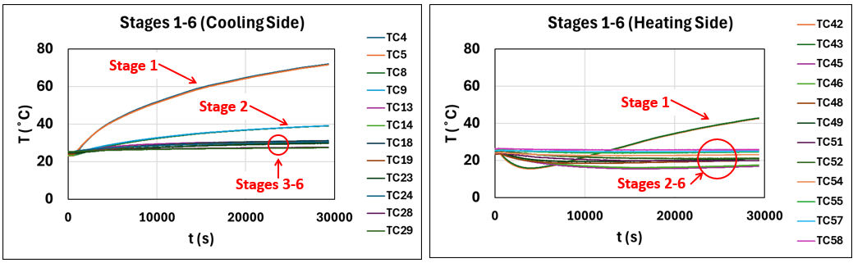
Fig. 7 Temperature measurements of both the heating and cooling sides of Stages 1-6. Note that no heating or cooling was applied.
- Testing the TAHP with turning on a stage at a time
Another test was performed where the stages were turned on one at a time. Fig. 8 shows the temperature measurements along Stages 1-2. It can be seen that the thermoacoustic effect is noticed in Stage 2 (when Stage 1 was ON and Stage 2 was OFF). TCs 45-46 (heating side of Stage 2) continued to drop to around 0˚C until Stage 2 was turned on. In addition, TCs 8-9 (cooling side of Stage 2) was getting warmer due to the thermoacoustic effect. Similar behavior was noticed when the rest of stages were turned one a time (see Figs. 9-11). Note that the location of the thermocouples plotted in Figs. 8-11 are shown in each figure.
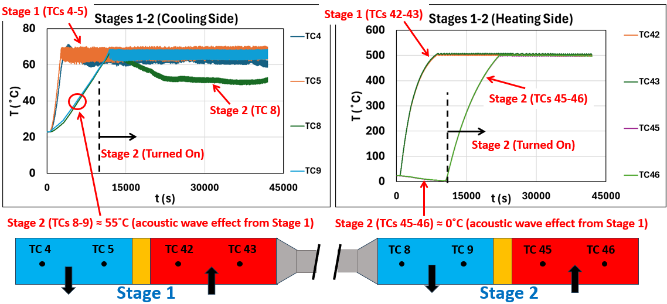
Fig. 8 Temperature measurements of both heating and cooling sides of Stages 1 and 2. The black arrows indicate the heat direction (e.g., heat addition to the TAHP or heat removed from the TAHP).
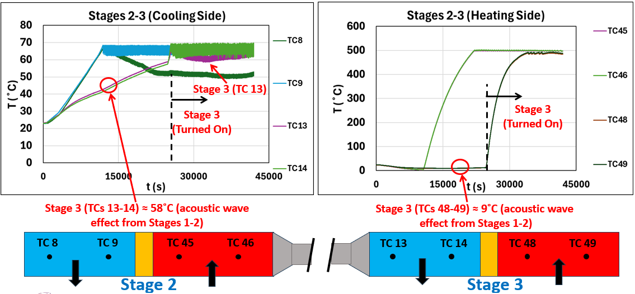
Fig. 9 Temperature measurements of both heating and cooling sides of Stages 2 and 3. The black arrows indicate the heat direction (e.g., heat addition to the TAHP or heat removed from the TAHP).
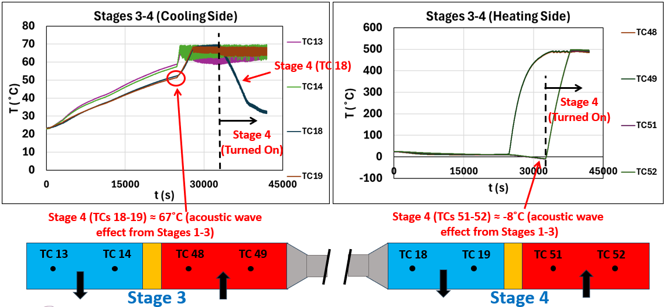
Fig. 10 Temperature measurements of both heating and cooling sides of Stages 3 and 4. The black arrows indicate the heat direction (e.g., heat addition to the TAHP or heat removed from the TAHP).
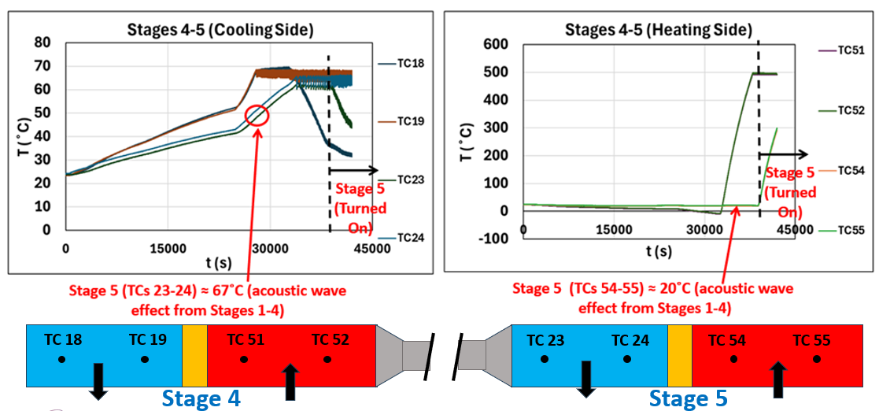

Fig. 11 Temperature measurements of both heating and cooling sides of Stages 4 and 5. The black arrows indicate the heat direction (e.g., heat addition to the TAHP or heat removed from the TAHP).
- Testing the TAHP under the design operating conditions
Figures 12-13 show a photo of Stage 7 and the thermosyphon and the temperature measurements along them, respectively. It can be seen that the thermoacoustic heat pump successfully transferred the heat to the thermosyphon evaporator while maintaining the refrigeration side at a lower temperature. However, due to substantial heat leaks from the thermosyphon evaporator to the refrigeration side, the refrigeration side cannot reach the expected design temperature (8˚C). It is worth noting that the thick-wall stainless steel envelope was selected due to the limited time, budget, and supply chain constraints. For improved thermal performance, titanium with thin walls can be used as the envelope of the TAHP. Due to the substantial heat leaks, no heat source was applied to the refrigeration side of this stage.
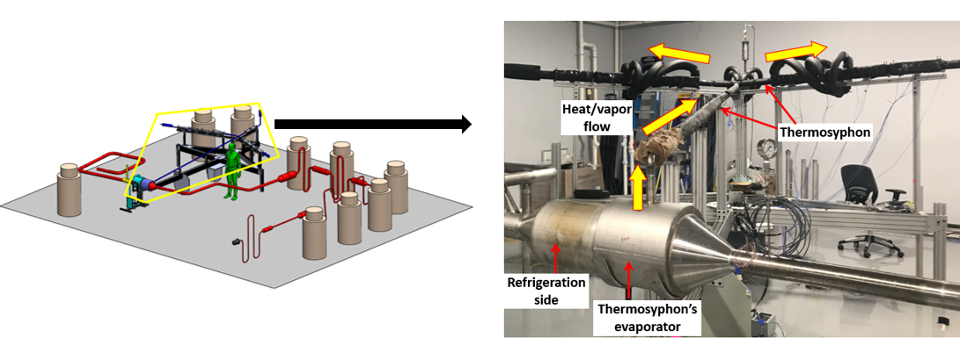
Fig. 12 A photo of Stage 7 and the thermosyphon.

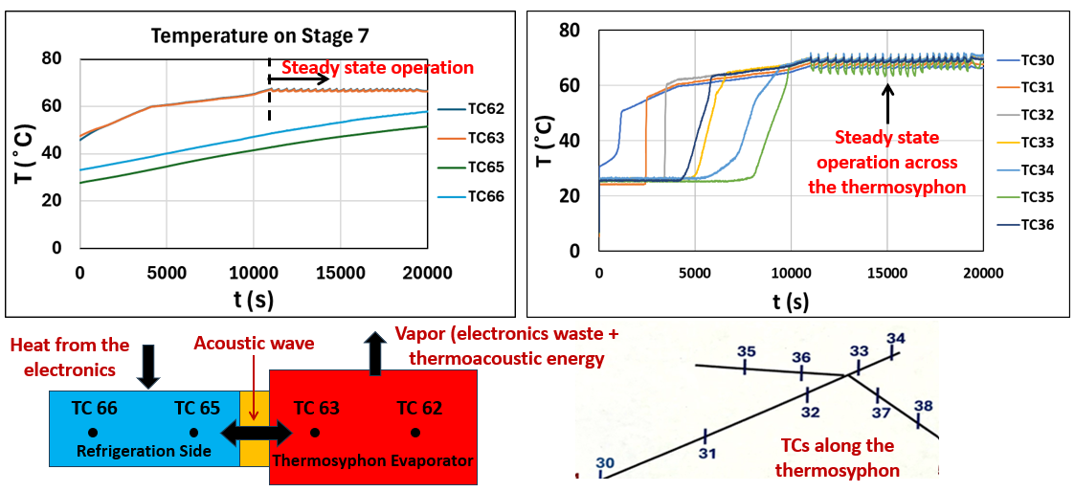
Fig. 13 Temperature measurements at Stage 7 (i.e., thermosyphon evaporator and refrigeration side) and along the thermosyphon. The black arrows indicate the heat direction.
- Conclusions and Future Work
Under a NASA SBIR Phase III program, ACT manufactured and demonstrated a complete thermal management system incorporating the thermoacoustic heat pump (TAHP) designed by NASA GRC and the water-titanium thermosyphon and loop thermosyphon (LTS) by ACT. This is the first demonstration of a large-scale fully integrated high-power thermal management system with no moving parts based on thermoacoustic refrigeration for future MW-class aircraft. Promising results were obtained from the EDU. Future work would include optimizing the material selection and heat exchanger designs.

Acknowledgments

This project was funded by NASA Glenn Research Center under a SBIR Phase III program (Contracts numbers: 80NSSC22CA024 and 80NSSC23CA197). The technical monitor was Dr. Rodger Dyson. The authors would like to thank Jonathon Murray, Jacob Gross, Sam Martzall, Philip Texter, Eugene Sweigart, and Larry Waltman for providing technician support on this project at ACT.

References
[1] | L. Rodriguez, R. Dyson, M. Wernet and R. and Leibach, "Thermoacoustic Thermal Management for Electric Aircraft," in AIAA SCITECH 2025 Forum (AIAA 2025-1477), Orlando, FL, 2025.
[2] | R. Dyson, "Novel Thermal Energy Conversion Technologies for Advanced Electric Air Vehicles," in AIAA Propulsion and Energy Forum, Cincinnati, 2018.
[3] | J. Diebold, C. Tarau, K. Lee, W. Anderson and R. and Dyson, "Electric Aircraft Thermal Management Using a Two-Phase Heat Transport System with Solid State Thermal Switching Capability," in AIAA Propulsion and Energy Forum , 2021.
[4] | R. Dyson, L. Rodriguez, M. Roth and P. and Raitano, "Solid-State Exergy Optimized Electric Aircraft Thermal and Fault Management," in AIAA/IEEE Electric Aircraft Technologies Symposium (EATS), New Orleans, LA, 2020.
[5] | R. Abdelmaksoud, J. Diebold, Z. Ahmed, B. Leitherer, C. Tarau, K. Lee and R. and Dyson, "Status of Development of a Solid-State Thermal Management System of a MW-Scale Electric Aircraft," in AIAA SCITECH 2024 Forum (AIAA 2024-2364), Orlando, FL, 2024.
[6] | J. Diebold, K. Lee, C. Tarau and W. and Anderson, "Development of Solid-State Waste Heat Delivery System for Electric Aircraft," in 20th IEEE ITherm Conference, 2021.
[7] | J. Diebold, B. Leitherer, C. Tarau and K. and Lee, "Development of a Large-Scale Thermosyphon for Cooling the Fault Management System of a MW-Scale Electric Aircraft," in AIAA SCITECH 2023 Forum, 2023.

R&D Engineer III, Advanced Cooling Technologies Inc.
R&D Principal Engineer, Advanced Cooling Technologies Inc.
R&D Lead Engineer, Advanced Cooling Technologies Inc.
R&D Lead Engineer, Advanced Cooling Technologies Inc.
Space and Aeronautics Research Engineer, Thermal Energy Conversion Branch, and AIAA Member.
Chief, Thermal Energy Conversion Branch, and AIAA Member.

